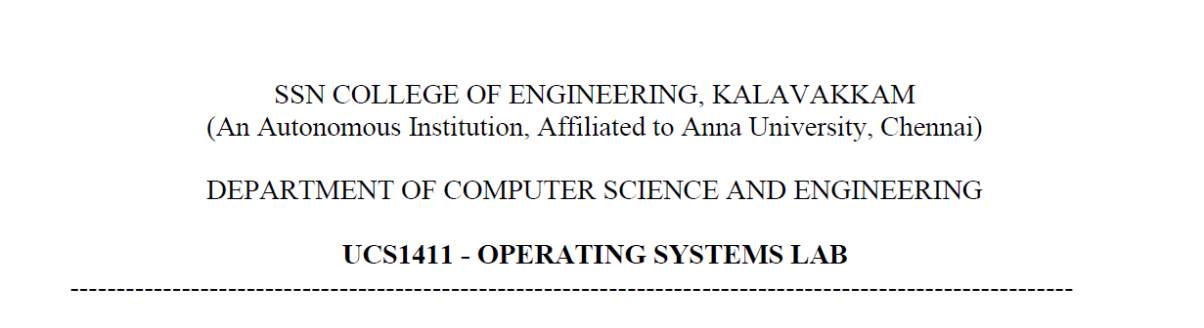

**OOAD**

Name: Jayannthan P T

Dept: CSE ‘A’

Roll No.: 205001049

Online Dental Clinic Management System

1.Identify the main functionalities and draw overall use case diagram for the main success scenario.

**Main Functionalities:**

* Managing User Database
* Appointment management
* Patient information management
* Medical and dental record management
* Treatment management
* Billing management

**Use cases for each actor in the Online Dental Clinic Management System:**

**Administrator:**

* Modify Database
* Generate reports
* View clinic statistics

**Receptionist:**

* Schedule appointment
* Reschedule appointment
* View patient information
* Add new patient information
* Generate invoice

**Patient:**

* Schedule appointment
* Reschedule appointment
* Make payment

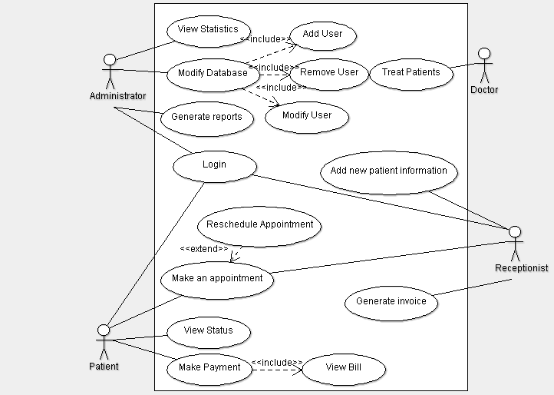

2.Draw / design a use case diagram for any one of the main functionalities

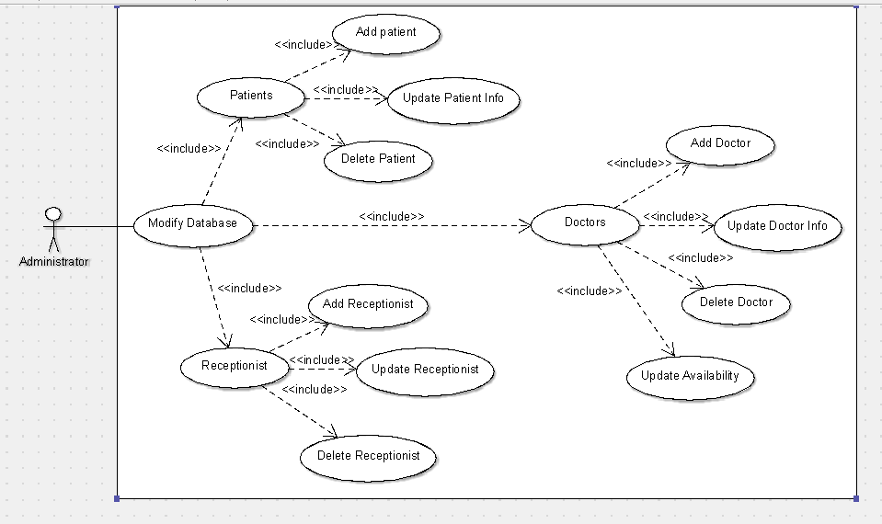

3.Draw / design a use case diagram depicting any one possible failure case

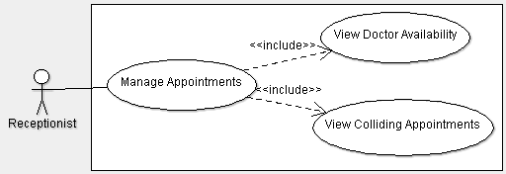

4. Identify the concepts involved draw/ design the domain and class diagram with the relationships

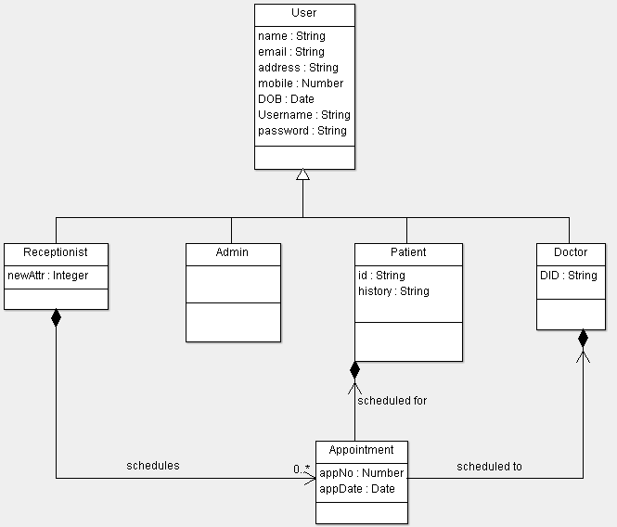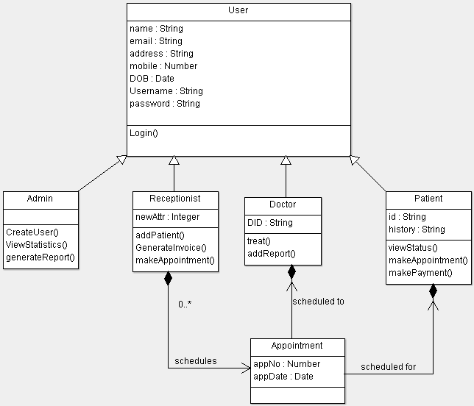

\

5. Draw / design the overall sequence diagram for the entire application

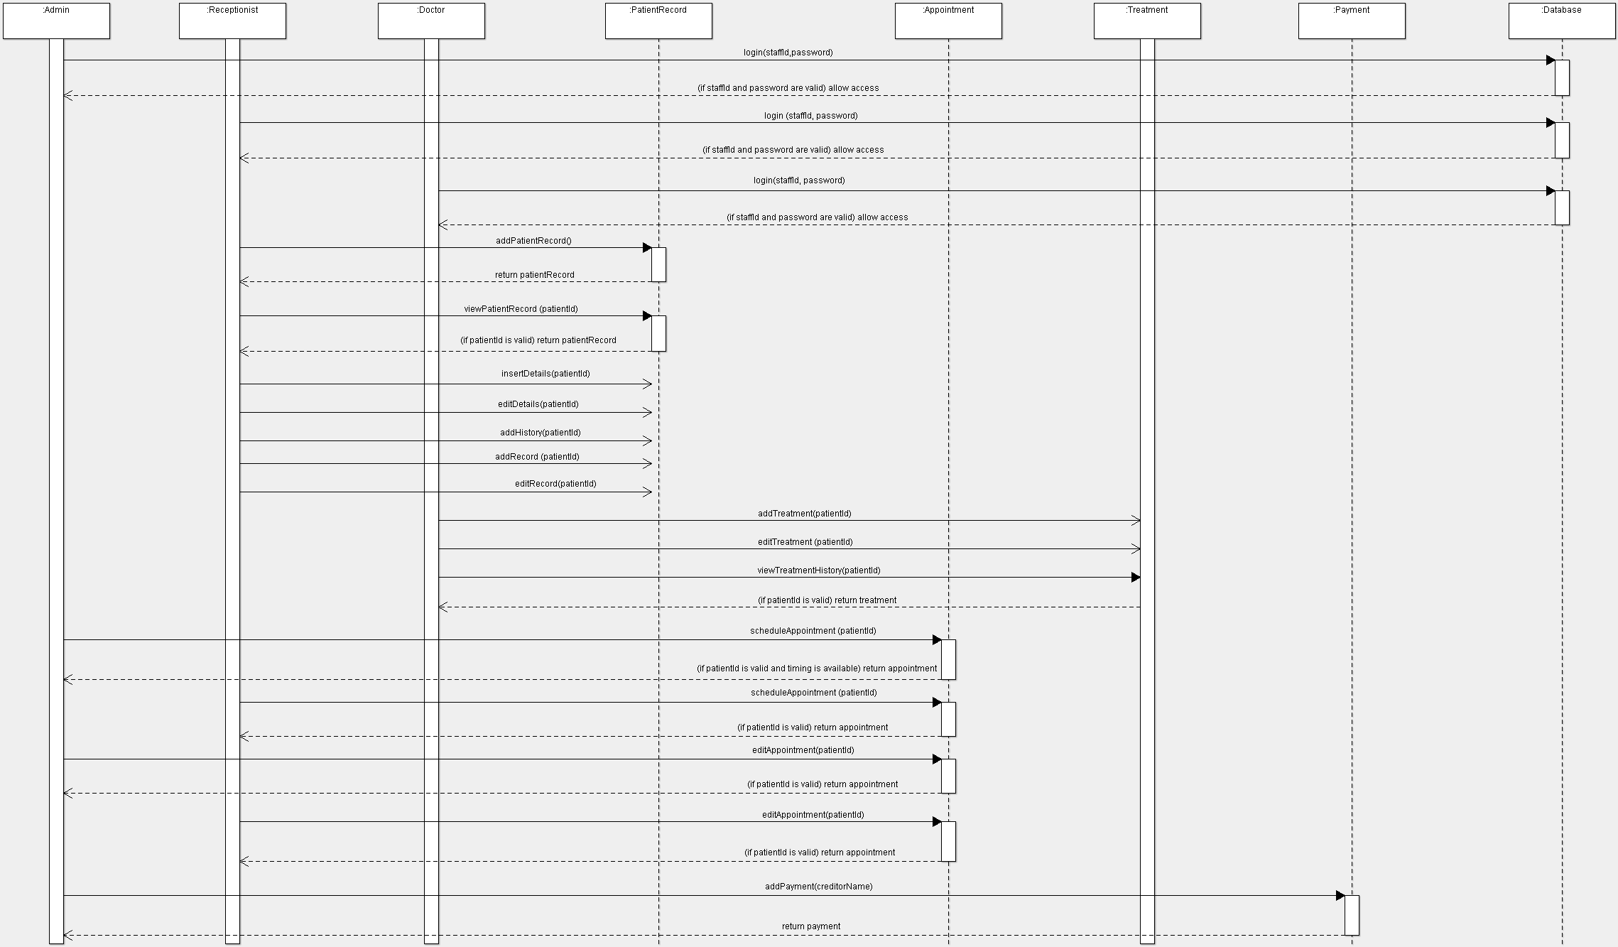

6. Draw / design the overall collaboration diagram for the entire application

